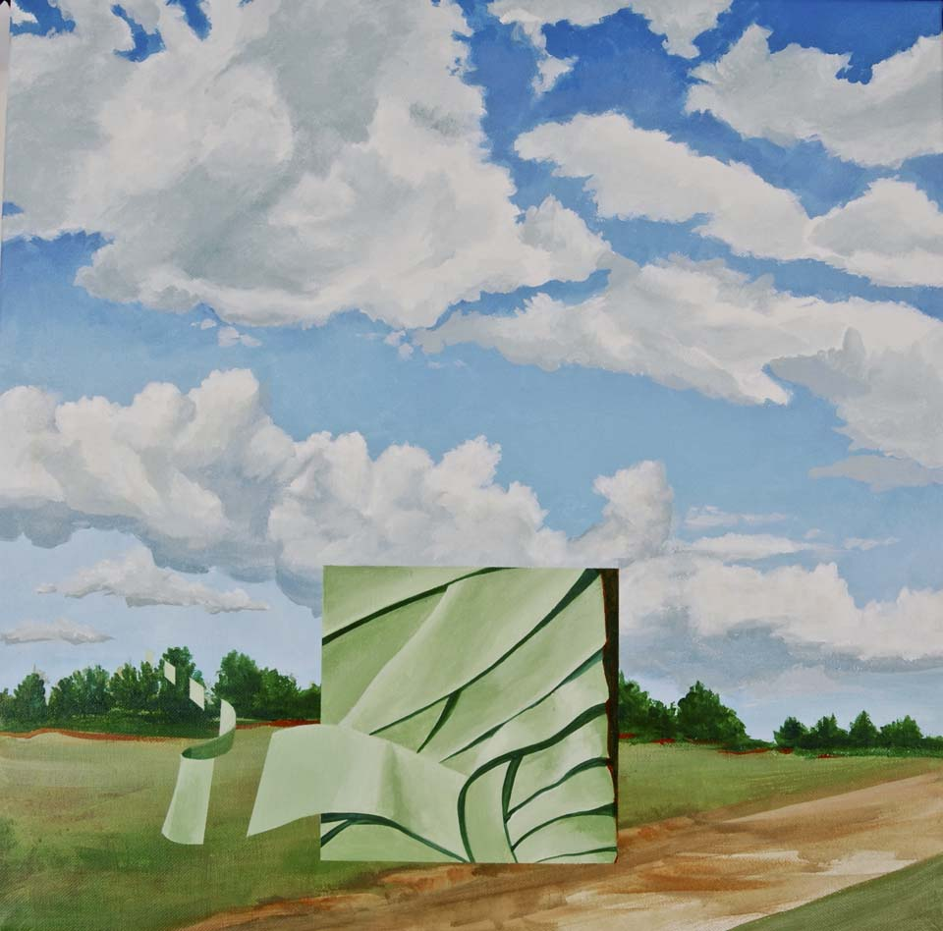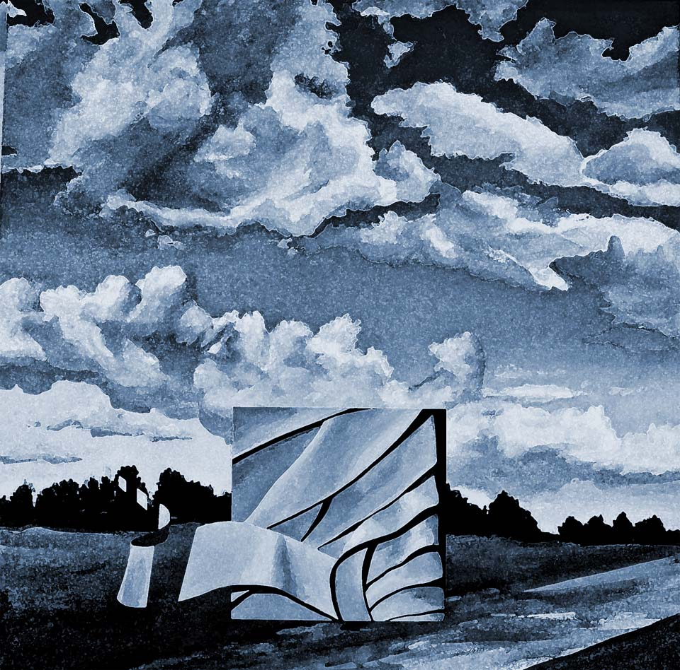

Lesson #1 adjustments

• Duplicate the photo of your painting. Name your copy the name of your painting and “after”. Label your original the name of your painting and “before”.

• Create a folder titled lesson #1 where both jpgs will be filed.

• Open your abstract painting in Photoshop.

• Jump the background layer by using the command key and the letter J.

• With this layer selected in blue, open the adjustment panel, window< adjustment in drop down menu.

• Hover over the symbols until you see their names. Select Hue saturation first, and modify the hue in a way that you like.

• When you click on an adjustment symbol, a new window will open. Experiment with the controls of the following adjustments until you find one you like. Then select another adjustment with which to experiment. Choose the following adjustments: 1. Hue saturation
2. Posterize
3. Invert
4. Gradient
5. Channel mixer
• The eye in the left hand box of the layer in the layers panel allows you to see that layer. Click on the eyeball in the layer directly above your jumped level titled layer.

• Drag up through all the eyeballs to make them disappear. This will show you your beginning image.

• Click on eyeballs to see the numbers of variations you have created. How many variations do you count?

• Save your work as “name of painting after” and store in your lesson #1 folder with the original titled “name of your painting before” and these instructions.

